EMAIL SUBJECT LINE: 2025 WTCA China International Import Expo (CIIE) Program Now Open to All WTCA Members and their Business Networks
2025 WTCA CIIE PROGRAM

Add your WTC logo here

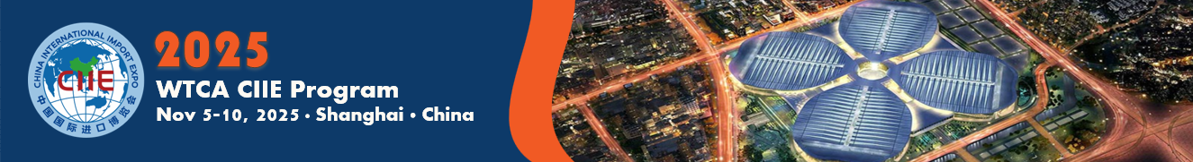
Dear [INSERT NAME],

As a valued member of World Trade Center (WTC) [INSERT CITY], you are cordially invited to join us for the 2025 WTCA CIIE program, a hybrid program at the China International Import Expo (CIIE), the top trade show for imported goods in China, to be held November 5-10, 2025 in Shanghai. Partnering with WTC Shanghai – which is operated by the Shanghai branch of CCPIT, the nation’s top trade promotion agency – the 2025 WTCA CIIE program provides free remote participation for convenient and cost-effective access by overseas WTCA Members and their business networks, as well as an in-person booth managed by WTCA staff to allow for face-to-face interaction with potential buyers.

Organizations wishing to attend the 2025 CIIE in person are encouraged and welcomed. All participating organizations and products will also be promoted to local Chinese business communities by WTCA Members, and WTCA partners in Shanghai and other cities throughout China.

Last year's WTCA CIIE program saw participation from 36 enterprises from seven overseas World Trade Center businesses, bringing a total of 120 products and services from five major industries including Food and Agriculture, Consumer Goods, Trade Services, Healthcare, and Intelligent Industry and Information Technology.

About China International Import Expo (CIIE)
The 8th annual China International Import Expo (CIIE) will take place in Shanghai – China’s business and trade hub – from November 5-10, 2025. As the top trade show for imported goods, CIIE exhibition covers a wide range of industries, including:
- Food and Agricultural Products
- Automobiles
- Intelligent Industry & Information Technology
- Consumer Goods
- Medical Equipment & Healthcare Products
- Trade in Service

CIIE 2024 Highlights in Numbers
- 77 countries and international organizations at Country Exhibition
- 3,496 exhibitors at Business Exhibition
- 297 of the world’s top 500 companies and industry giants at business exhibition
- 450 representative new products, technologies and services debuted
- USD $80.01 billion worth of tentative deals reached for one-year purchases of goods and services

2025 WTCA CIIE Participant Benefits
- CIIE Booth Promotion – managed by WTCA Asia Pacific Regional Office (APRO) team (the WTCA booth will be located in the Trade in Services exhibition hall and is comprised of two standard booths (3x6 meters for a total of 18 square meters).
- Admission/Name Badge – WTCA assists CIIE admission tickets/name badges for in-person participants (deadline September 19).
- Meeting Point – In-person participants are welcome to book pre-scheduled timeslots at the WTCA CIIE booth to meet with their clients/leads.
- Products Display – limited amount of product display may be accepted, as the WTCA CIIE booth space allows and if products are already cleared by Chinese Customs. No direct shipment from overseas is accepted.
- Booth Booklet – your company profile and products to be included in the 2025 WTCA CIIE Program Booklet (translation provided by WTCA APRO team if you don’t have Chinese version).
- Local Support – local support and business promotion to be provided by WTC Shanghai.
- Virtual Meeting – might be arranged when both seller and buyer show interests.
- Complimentary Participation – cost-saving as virtual participation is complimentary for WTCA Members and their business networks.
- Additional Promotion by China-based WTCA Members and Partners – promotional services with local business communities will be offered by Chinese WTCA Members and partners.

To learn more about CIIE, please click here.

To participate, please download the Profile Form here and Product & Service Form here, and return to [INSERT NAME OF WTC COORDINATOR] at [INSERT EMAIL ADDRESS] by [INSERT DEADLINE].

You don’t want to miss this opportunity! We look forward to your participation.

Best regards,
[INSERT YOUR SIGNATURE WITH CONTACT INFORMATION/WTC INFORMATION]

